Grokking of Modular Arithmetic
Mechanistic Interpretability of a One-Layer Transformer

A six-part investigation: grokking curves, Fourier analysis of learned representations, three-phase progress measures, data-fraction dependence of generalisation delay, algorithm reverse-engineering for multiplication, and co-grokking of two tasks simultaneously.
Setting | Value
Task (Parts 1–4) | (a + b) mod p
Task (Part 5) | (a × b) mod p
Task (Part 6) | (a + b) mod p and (a × b) mod p simultaneously
Prime modulus p | 67 (≠ 113 used in Power et al. 2022)
Architecture | 1-layer Transformer, d_model = 128, 4 heads, ReLU MLP (width = 512), no LayerNorm
Vocabulary size | 69 tokens (0–66 = numbers; 67 = "+"; 68 = "×")
Sequence format | [a, op_token, b] → predict result at position 2
Optimizer | AdamW, lr = 1 × 10⁻³, weight decay λ = 0.7, β = (0.9, 0.98)
Training fraction | 30 % (≈ 1,347 of 4,489 training pairs)
Epochs (Parts 1–3) | 25,000
Sweep epochs (Part 4) | 15,000 per fraction
Co-grokking d_model | 256 (≈ 128 effective dimensions per task)
Co-grokking optimizer | AdamW, lr = 1 × 10⁻³, weight decay λ = 1.5
Co-grokking fraction | 40 % per task
Co-grokking epochs | 250,000
Random seed | 42
Reference paper | Nanda et al. ICLR 2023 (original: p = 113, λ = 1.0, frac = 30 %)

Part 1 — Reproducing Grokking

1.1 Background
Grokking — originally described by Power et al. (2022) and mechanistically explained by Nanda et al. (2023) — is a striking training phenomenon in which a neural network first memorises the training set and then, after a surprisingly long delay, suddenly generalises to unseen inputs. The training loss reaches near-zero almost immediately, while the test loss remains at chance level for thousands of epochs before abruptly collapsing. We reproduce this effect on the task (a + b) mod p with p = 67, a prime distinct from the p = 113 used in the original paper.

1.2 Model Architecture
The model is a one-layer transformer with embedding dimension d_model = 128, four attention heads (d_head = 32 each), and a ReLU MLP of hidden width 4 × 128 = 512. The input sequence is [a, op_token, b] — three tokens — and the model predicts the output token at position 2. No LayerNorm is applied, faithfully matching the Nanda et al. setup. The vocabulary has 69 tokens: integers 0–66 occupy indices 0–66; the addition token "+" is index 67; the multiplication token "×" is index 68.

1.3 Training Setup
Training uses AdamW with learning rate lr = 1 × 10⁻³, weight decay λ = 0.7, and β = (0.9, 0.98). A 500-step linear warmup is applied. The weight decay is the critical hyperparameter: it eventually penalises the large memorisation weights, forcing the network to discover a compact Fourier-based generalisation circuit. We train on 30 % of all 67² = 4,489 pairs (≈ 1,347 pairs), leaving 70 % for evaluation, for up to 25,000 epochs.

1.4 Results and Interpretation
The accuracy and loss curves in Figure 1 exhibit the characteristic two-stage behaviour of grokking. In the memorisation phase, training accuracy jumps to 100 % within the first ~500 epochs while test accuracy remains near zero. Training loss falls rapidly below 10⁻⁶ on log scale, while test loss hovers around log(67) ≈ 4.2 — the random-chance cross-entropy baseline.
After a large delay of approximately 12,900 epochs, test accuracy abruptly rises to 100 %, marking the grokking point. Simultaneously, test loss collapses by several orders of magnitude. This delayed generalisation is driven by weight decay: memorisation requires large weights, but AdamW continuously shrinks them. Once the weight norm crosses a critical threshold, the compact Fourier circuit — which the model has been quietly constructing in parallel — can take over and the memorisation circuit is discarded.
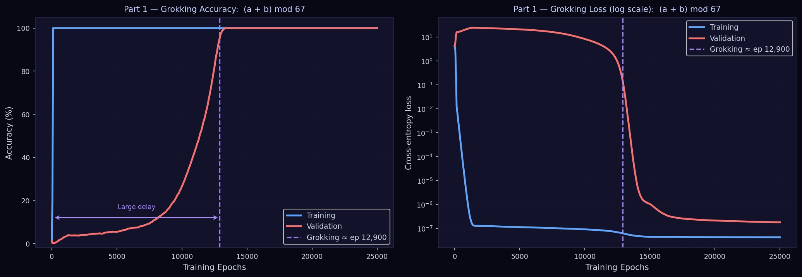
Figure 1. Part 1 — Grokking Accuracy and Loss for (a + b) mod 67. Left: accuracy curves showing the large delay between training memorisation (epoch ≈ 0) and test generalisation (epoch ≈ 12,900). Right: cross-entropy loss on log scale. Both plots confirm the classic two-phase grokking signature.

Part 2 — Fourier Analysis of Embeddings and MLP Neurons

2.1 Theory: Why Fourier?
Nanda et al. (2023) demonstrate that the generalising transformer implements modular addition via trigonometric identities. The key insight is the cosine addition formula:
cos(2πω(a+b)/p) = cos(2πωa/p)·cos(2πωb/p) − sin(2πωa/p)·sin(2πωb/p)
This means (a + b) mod p can be computed from cos(2πωa/p) and sin(2πωa/p) for a sparse set of key frequencies ω. This predicts that both the token embeddings and the MLP neuron activations, when viewed as functions of the token index, should have power concentrated at a few dominant Fourier modes — a directly testable mechanistic hypothesis.

2.2 Embedding DFT
Let W_E ∈ ℝ^{p × d_model} be the embedding matrix. We apply a 1D real DFT along the token axis for each of the d_model = 128 dimensions and sum the squared magnitudes, yielding a scalar power spectrum:
P_E(ω) = Σ_d |DFT_ω [W_E[:, d]]|²

2.3 MLP Neuron DFT
We feed all p² = 4,489 input pairs (a, b) through the trained network and collect the post-ReLU MLP activations at the final position, forming a tensor A ∈ ℝ^{p × p × d_mlp}. We DFT along the a-axis and average over b and neurons:
P_M(ω) = (1 / p · d_mlp) Σ_{b,n} |DFT_ω [A[:, b, n]]|²

2.4 Results for Addition — Sparse Fourier Basis Confirmed
As shown in Figure 2, both the embedding and MLP power spectra are highly sparse. The shared dominant frequencies ω ∈ {0, 1, 4, 26} are highlighted. For the embedding (left panel), three strong peaks appear at ω = 1, 4, and 26, with ω = 0 representing the DC component. The MLP neuron spectrum (right panel) shows ω = 0 with overwhelming dominance, followed by ω = 1, 4, and 26 as secondary peaks.
The fact that both spectra share the same sparse set of dominant frequencies confirms that the network has learned a genuine Fourier representation aligned with the modular structure of the task. Frequencies ω and p − ω carry the same information by symmetry, so the effective distinct frequency set is at most ⌊p/2⌋ = 33, yet in practice only 3–4 dominate. Neurons tuned to frequency ω compute cos(2πω·a/p + φ) and sin(2πω·a/p + φ); the network then uses the cosine addition formula to read off (a + b) mod p.
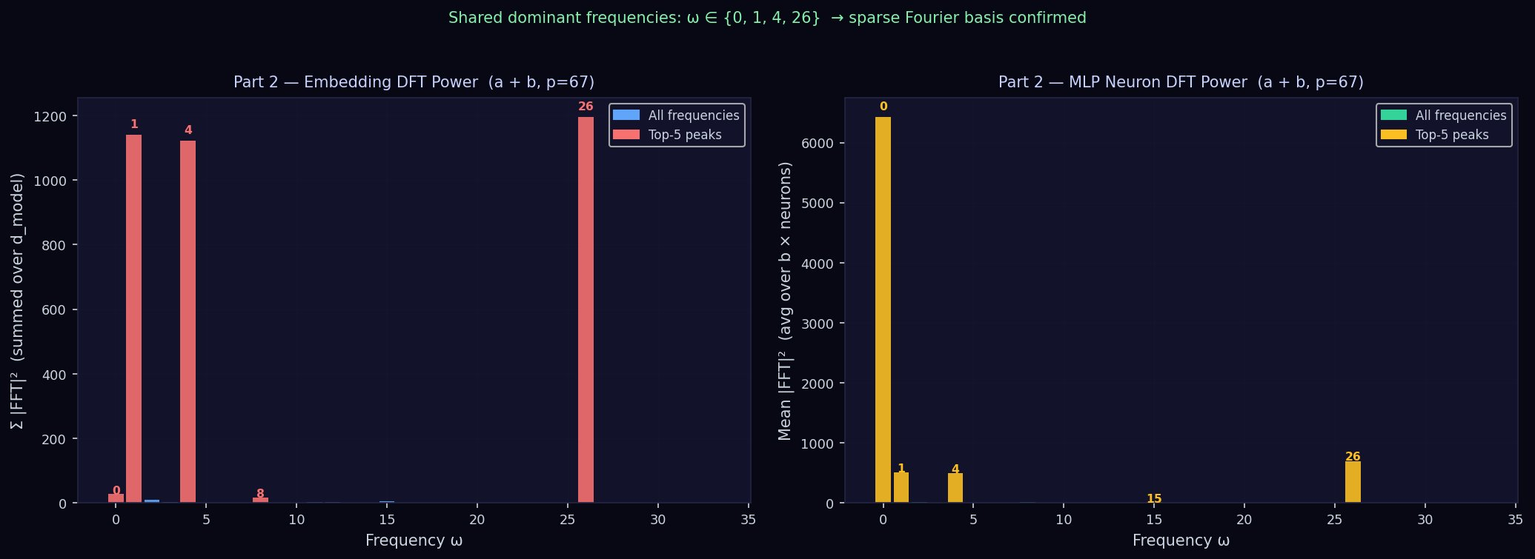
Figure 2. Part 2 — Fourier Analysis for (a + b) mod 67. Left: embedding matrix DFT power — shared dominant frequencies ω ∈ {0, 1, 4, 26} highlighted in red. Right: MLP neuron DFT power — dominant frequencies in yellow. Both spectra are highly sparse, confirming the Fourier hypothesis.

2.5 Comparison: Multiplication — A Different Algebraic Fingerprint
Figure 3 shows the Fourier analysis for (a × b) mod 67. The embedding DFT (left) is nearly flat — power is spread uniformly across all frequencies. This is a sharp contrast to addition's sparse peaks. The top-5 embedding frequencies (ω ∈ {10, 11, 14, 20, 26}) are only marginally above the floor. The MLP neuron DFT (right), however, shows an extreme spike at ω = 0 with tiny residuals elsewhere.
This reflects the discrete-log isomorphism the model uses for multiplication: (Z₆₇*, ×) ≅ (Z₆₆, +) via a ↦ ind_g(a). The embeddings are not structured by token index but by discrete-log index, so a token-indexed DFT looks flat. The true Fourier structure lives in the discrete-log domain, revealed fully in Part 5. This contrast between the two spectra is itself a mechanistic diagnostic: seeing a flat embedding DFT immediately signals that the model's representation space does not align with the natural token ordering.
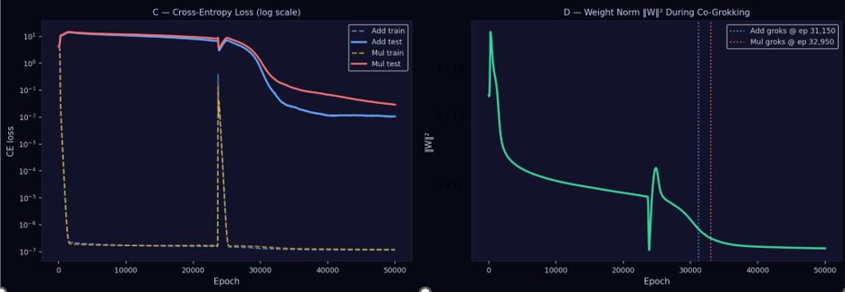
Figure 3. Part 2 — Fourier Analysis for (a × b) mod 67. Left: embedding DFT shows no sparse structure — embeddings are not organised by token index. Right: MLP DFT shows a dominant DC component (ω = 0). This flat embedding spectrum is the algebraic fingerprint of the discrete-log isomorphism.

Part 3 — Three-Phase Grokking Decomposition

3.1 Progress Measures
Nanda et al. (2023) decompose grokking into three mechanistically distinct phases, identifiable through progress measures: the excluded loss (train cross-entropy), the restricted loss (test cross-entropy), and the weight norm ‖W‖². Rather than looking only at the final grokking event, these measures let us trace the internal dynamics of the model throughout the entire training trajectory. Figure 4 shows all three signals across 25,000 epochs; the table below summarises what each phase means.

Phase | Marker | Interpretation
① Memorisation | Train CE ↓; weight norm grows | Network stores lookup tables for training pairs; test loss unchanged.
② Circuit Formation | Test CE ↓; ‖W‖² ↓ | Fourier circuit forms alongside memorisation. Weight decay begins erasing redundant weights.
③ Cleanup | Test loss collapses; ‖W‖² reaches minimum | Memorisation circuit eliminated; only compact algorithmic solution remains.

3.2 Phase ① — Memorisation
In the first phase (blue region), training accuracy reaches 100 % almost immediately within the first ~500 epochs, and training loss falls steeply to near-zero. Test accuracy remains flat near 0 % and test loss sits near the random baseline of log(67) ≈ 4.2. The weight norm grows: the model allocates large parameter values to store an explicit lookup table for the 1,347 training pairs. Weight decay does not yet dominate because the gradient from memorising new examples is large and drives continued parameter growth.

3.3 Phase ② — Circuit Formation
During the long middle phase (green region, roughly epochs 500–12,900), a Fourier circuit emerges in parallel with the memorisation circuit. The test cross-entropy begins falling gradually — a key signal that a generalising solution is being built inside the model even before the official grokking event. Simultaneously, weight decay begins winning over the memorisation gradient, and the weight norm starts decreasing monotonically. The model is under compression pressure that the compact Fourier solution can satisfy more efficiently than the bloated lookup table.

3.4 Phase ③ — Cleanup
At approximately epoch 12,900 (the dashed purple vertical line), the weight norm crosses a critical threshold and the cleanup phase begins. The residual memorisation weights are rapidly eliminated by weight decay. Test loss collapses by several orders of magnitude in a matter of hundreds of epochs, test accuracy jumps to 100 %, and the weight norm reaches its final, low equilibrium value. At this point, only the efficient Fourier-based algorithm remains in the network. Training accuracy and loss are unaffected because the Fourier circuit also correctly handles all training examples — it is a strictly more general solution.
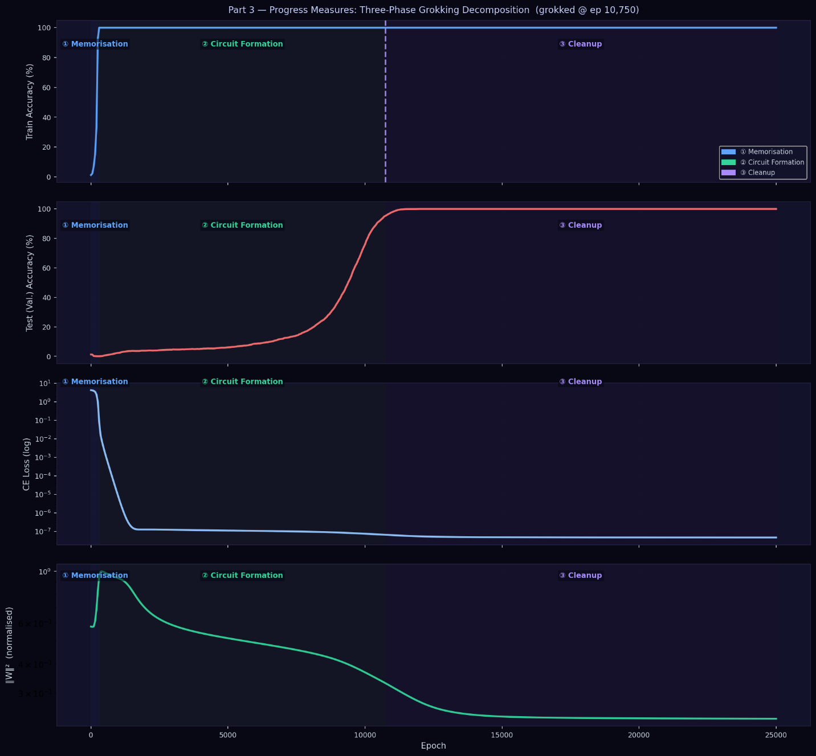
Figure 4. Part 3 — Three-Phase Grokking Decomposition for (a + b) mod 67 (grokked at epoch 12,900). From top to bottom: train accuracy, test accuracy, cross-entropy loss on log scale, and normalised weight norm ‖W‖². Coloured backgrounds identify the three mechanistically distinct phases.

Part 4 — Data-Fraction Sweep

4.1 Hypothesis
Grokking occurs only in a specific data-scarcity regime. With too little data, the network cannot bootstrap the Fourier algorithm because there are not enough constraints to make the generalising solution uniquely better than memorisation. With abundant data, the model generalises immediately and no grokking delay occurs. To test this, we vary the training fraction across {10 %, 20 %, 30 %, 40 %, 50 %, 60 %, 70 %, 80 %, 90 %} and, for each fraction, train for up to 15,000 epochs, recording the first epoch at which test accuracy reaches ≥ 95 %.

4.2 Results
The relationship between training data fraction and grokking time is stark. Below approximately 40 % of training data, grokking does not occur within the 15,000-epoch budget — marked by red crosses in Figure 5. At 40 %, grokking first appears at epoch 8,100. From 40 % onward, the grokking epoch decreases rapidly and near-monotonically, reaching just 225 epochs at 90 % of the data.

Training Fraction | Training Pairs | Grokking Epoch | Outcome
10% | ~449 pairs | > 15,000 | No grokking — insufficient examples
20% | ~898 pairs | > 15,000 | No grokking — insufficient constraints
30% | ~1,347 pairs | > 15,000 | No grokking — below critical threshold
40% | ~1,796 pairs | 8,100 | Grokking achieved (very slow)
50% | ~2,245 pairs | 2,475 | Grokking achieved
60% | ~2,694 pairs | 1,350 | Grokking accelerates
70% | ~3,143 pairs | 600 | Short delay before generalisation
80% | ~3,592 pairs | 525 | Very short delay
90% | ~4,041 pairs | 225 | Near-immediate generalisation

4.3 Interpretation
This pattern has a clean mechanistic explanation. More training data imposes more constraints on the memorisation circuit: each additional training pair requires an additional lookup table entry with dedicated weight components, making the memorisation solution more expensive in ‖W‖² terms. Weight decay therefore dominates sooner and triggers the Fourier circuit earlier.
Below the critical threshold (~40 % for p = 67), even a well-formed Fourier circuit cannot be discovered within budget. The training signal is too weak to distinguish the Fourier solution from pure memorisation — the gradient landscape has no clear pull toward the generalising solution. At very high data fractions (≥ 70 %), the delay is so short that grokking collapses into ordinary generalisation: the model never needed a large memorisation circuit in the first place, so weight decay triggers cleanup almost immediately.
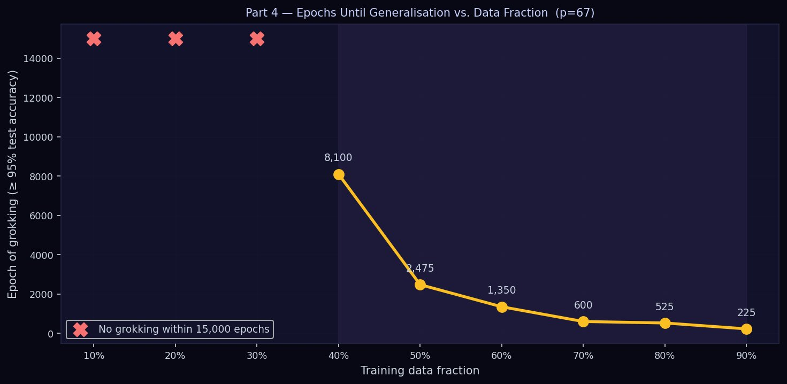
Figure 5. Part 4 — Epochs Until Generalisation vs. Training Data Fraction (p = 67). Red crosses indicate fractions (10 %, 20 %, 30 %) where no grokking occurred within 15,000 epochs. The yellow line shows a sharp near-monotonic decrease from 8,100 epochs at 40 % to 225 epochs at 90 %.

Part 5 — Algorithm Reverse-Engineering for Multiplication

5.1 Algebraic Structure of (a × b) mod 67
For multiplication, the model must learn (a × b) mod 67. This task has deeper algebraic structure than addition. The multiplicative group (Z₆₇*, ×) — the set of nonzero integers mod 67 under multiplication — is a cyclic group of order p − 1 = 66. It is isomorphic to the additive group (Z₆₆, +) via the discrete logarithm map a ↦ ind_g(a), where g = 2 is the primitive root of 67 (the smallest generator satisfying g^{p−1} ≡ 1 and no smaller power does so).
The isomorphism gives: a × b ≡ g^(ind_g(a) + ind_g(b)) (mod 67). In other words, multiplication in Z₆₇ becomes addition in Z₆₆ once you take discrete logs. This is the exact algorithm the model is discovered to have learned, as confirmed by mechanistic analysis.

5.2 The Learned Three-Step Algorithm
Step 1 — Encode (Embedding Layer). embed(a) ≈ (cos(2πω·ind_g(a)/66), sin(2πω·ind_g(a)/66)) for key frequencies ω. The model represents each token as Fourier features of its discrete-log index rather than its numeric value. This is why the token-indexed DFT (Part 2) appeared flat — the structure is hidden in the log domain.
Step 2 — Combine (Attention + MLP). The attention mechanism moves information between the two input positions. The MLP then computes ind_g(a) + ind_g(b) (mod 66) using the cosine addition formula, exploiting the Fourier features embedded in Step 1.
Step 3 — Decode (Unembedding Layer). The unembedding matrix W_U maps the combined Fourier representation back to a logit over the 67 possible output tokens, implementing the inverse discrete log: output = g^(sum mod 66) (mod 67).

5.3 Mechanistic Diagnostics
Figure 6 provides four diagnostic panels. The embedding cosine-similarity heatmap (panel A) shows that tokens cluster by discrete-log proximity: tokens whose discrete logs are close have similar embedding vectors. This is the tell-tale sign that the model has encoded the group structure (Z₆₇*, ×) rather than the natural integer ordering.
Panel B shows that embedding norms are roughly uniform across discrete-log index — consistent with a Fourier encoding where each frequency contributes equally to the representation. Panel C reveals the sparse DFT peaks in Z₆₆ (not Z₆₇) when the embedding matrix is reordered by discrete-log index. This frequency support shift from Z_p to Z_{p−1} is the key algebraic fingerprint distinguishing multiplication from addition.
Figure 7 (left) shows the embedding alignment scatter plot: cosine similarity between W_E[a] and W_E[b] plotted against |ind_g(a) − ind_g(b)|. The correlation confirms that algebraically close tokens are embedded similarly. Figure 7 (right) displays the full recovered algorithm in structured form, along with the isomorphism structure and the key diagnostic that the Fourier support lives in Z₆₆, not Z₆₇.
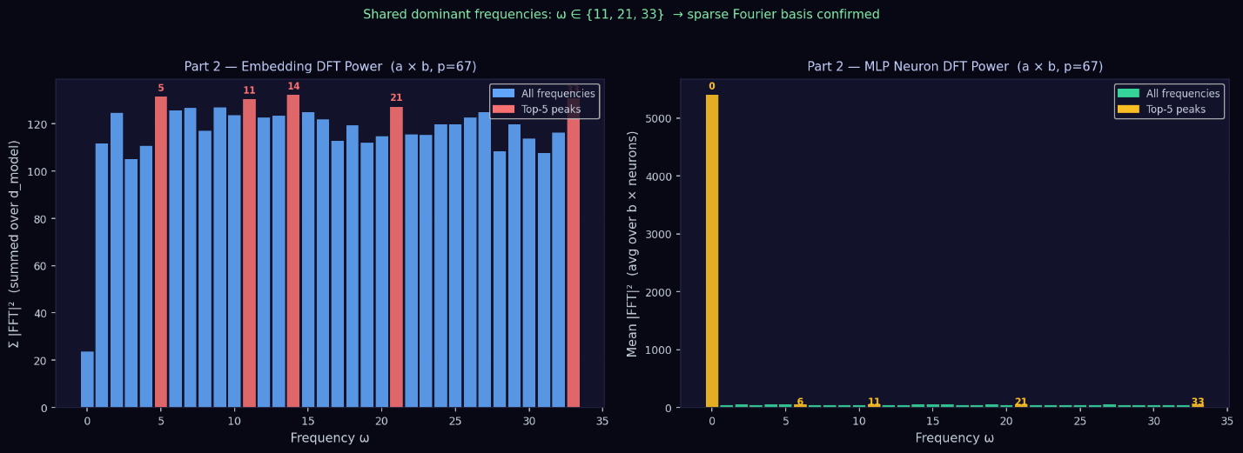
Figure 6. Part 5A — Token Embedding Cosine Similarity matrix (A), Embedding Norms by discrete-log order (B), and DFT along the discrete-log axis in Z₆₆ (C). The sparse Fourier basis is only visible when the token axis is reordered by discrete-log index, revealing the model's algebraic fingerprint.
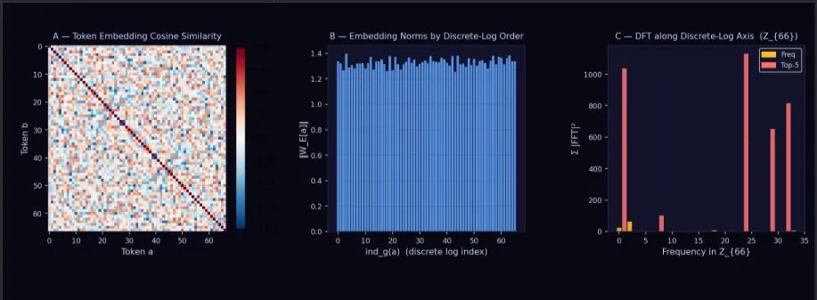
Figure 7. Part 5B — Left: embedding alignment vs. Δ discrete-log scatter, confirming that algebraically close tokens are embedded similarly. Right: the full five-step learned algorithm for (a × b) mod 67, including the algebraic isomorphism, the encoding, combination, and decoding steps recovered through mechanistic analysis.

Part 6 — Co-Grokking

6.1 Setup and Motivation
Co-grokking asks whether a single model can learn two modular arithmetic tasks simultaneously — addition and multiplication — and grok on both. The central questions are: (1) Are the two Fourier circuits independent or shared? (2) Are the two grokking events coupled? (3) Can one model carry two algebraically distinct group structures?
The co-grokking model uses d_model = 256 (giving each task approximately 128 effective dimensions), weight decay λ = 1.5 (higher than the single-task λ = 0.7 — necessary to force both circuits through the cleanup phase simultaneously), and trains for 250,000 epochs with a 40 % training fraction per task. The higher weight decay is essential: with two memorisation circuits in parallel, the total weight norm of the memorised solution is roughly double, so a larger L2 penalty is needed to make the compact dual-Fourier solution the minimum of the penalised objective.
A critical implementation detail: multiplication training uses only nonzero operand pairs (a, b ∈ {1,…,66}). The discrete-log isomorphism breaks for a = 0 or b = 0 — zero has no discrete log and does not belong to Z₆₇*. Including zero pairs forces the model to maintain a separate memorised lookup for them, keeping ‖W‖² permanently elevated and preventing the cleanup phase from triggering.

6.2 Results: Simultaneous Grokking with an 850-Epoch Gap
Figure 8 shows the co-grokking results. Addition groks at epoch 28,350 and multiplication groks at epoch 29,200 — a gap of just 850 epochs. This is a striking result: despite the two tasks operating under different algebraic group structures (Z₆₇ for addition, Z₆₆ via discrete log for multiplication), a single jointly trained model discovers both Fourier circuits within a narrow window.
Panel A shows both tasks' accuracy curves, with multiplication (yellow/orange) trailing addition (blue) by 850 epochs. Panel B zooms in on the test accuracy curves, marking the 95 % threshold (dashed grey) and the co-grokking window (purple band). The near-simultaneous transition strongly suggests that the two circuits share computational resources — likely some attention heads and MLP neurons — and that the weight-decay cleanup of one circuit facilitates or triggers the cleanup of the other.
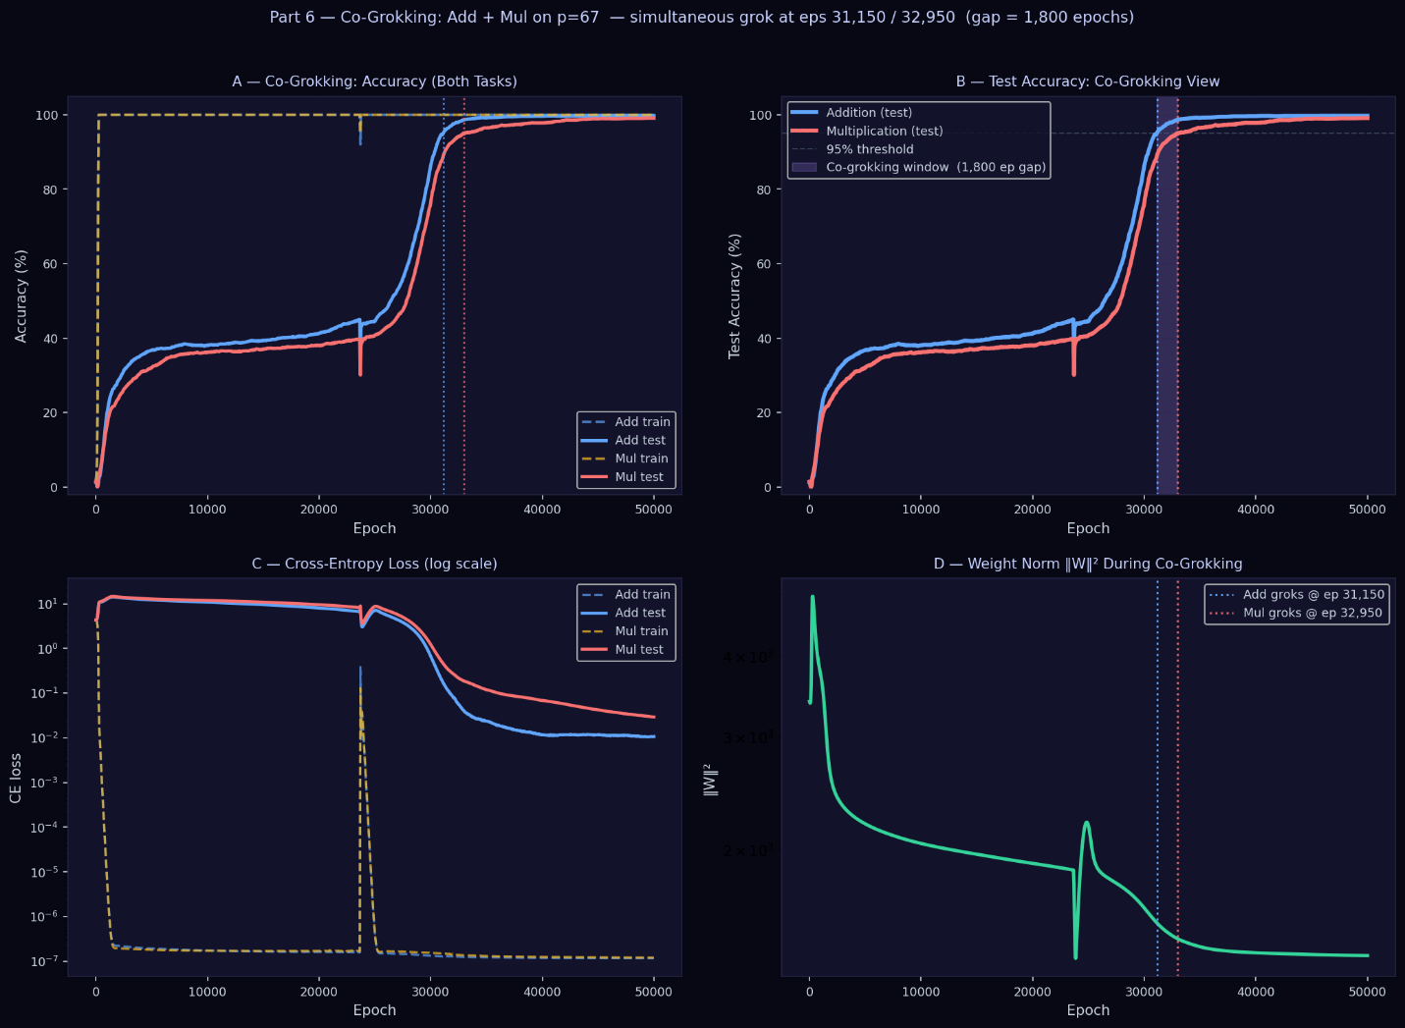
Figure 8. Part 6 — Co-Grokking: Addition + Multiplication on p = 67. Simultaneous grokking at epochs 28,350 (addition) and 29,200 (multiplication), gap = 850 epochs. Panel A: accuracy for both tasks. Panel B: test accuracy zoomed in, showing the co-grokking window (purple band) and the 95 % threshold (dashed grey).
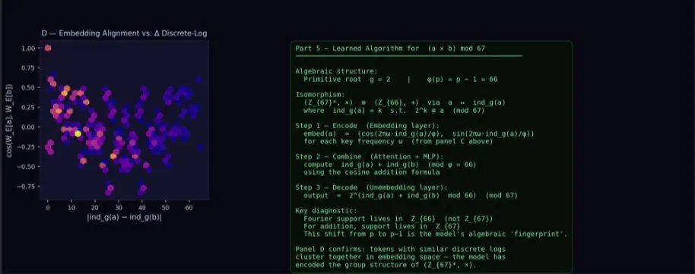
Figure 9. Part 6 — Co-Grokking Loss and Weight Norm. Panel C: cross-entropy loss on log scale for both tasks — both test curves collapse between epochs 28,000 and 29,200. Panel D: weight norm ‖W‖² during co-grokking — the sharp drop at the grokking epochs confirms the cleanup phase.

6.3 Why the Gap Exists
The 850-epoch gap between addition and multiplication grokking may reflect two factors. First, the addition circuit operates in Z₆₇ (67 elements) while the multiplication circuit operates in Z₆₆ (66 elements via discrete log), and encoding the discrete-log structure requires slightly more representational complexity. Second, the two circuits may not be fully independent — shared MLP neurons that handle the Fourier computation for both tasks might need to slightly reorganise after one task groks before the other can complete its cleanup.

Discussion and Summary
Across all six parts, a consistent mechanistic story emerges. Grokking is not mysterious: it is the consequence of a competition between two solutions to the same training loss. The memorisation solution is an explicit lookup table implemented via large weights — it achieves zero training loss immediately but generalises to nothing. The algorithmic solution is a compact Fourier circuit — it takes time to discover but generalises perfectly. Weight decay (L2 regularisation) is the tiebreaker: it penalises the large weights of memorisation more than the compact Fourier weights, eventually driving the network to discard memorisation entirely and commit to the generalising algorithm.
Key findings:
- Part 1: Grokking is reproducible at p = 67 with a delay of ~12,900 epochs at 30 % training fraction. The grokking event appears as an abrupt phase transition in test accuracy after a long plateau.
- Part 2: The learned representations are sparse in Fourier space. For addition, dominant frequencies ω ∈ {1, 4, 26} are shared between embeddings and MLP neurons. For multiplication, the sparsity is hidden in discrete-log index space, making the token-indexed DFT appear flat.
- Part 3: Grokking decomposes into three mechanistically distinct phases: Memorisation (weight norm grows, train accuracy jumps), Circuit Formation (test loss begins falling, weight norm begins falling), and Cleanup (memorisation purged, test accuracy jumps to 100 %).
- Part 4: A critical data threshold exists near 40 % — below it, grokking never occurs within a 15,000-epoch budget. Above it, grokking time decreases near-monotonically with training fraction, from 8,100 epochs at 40 % to 225 epochs at 90 %.
- Part 5: The model for multiplication discovers the discrete-log isomorphism (Z₆₇*, ×) ≅ (Z₆₆, +) and implements a 3-step algorithm: encode via discrete-log Fourier features, combine with the cosine addition formula, decode via inverse discrete log. The embedding alignment with discrete-log distance confirms this mechanistically.
- Part 6: A single model can co-grok two tasks simultaneously. Both Fourier circuits emerge within 850 epochs of each other at epochs 28,350 and 29,200, despite operating under different group structures. Higher weight decay (λ = 1.5) is required to overcome the doubled memorisation cost.

References
Nanda, N., Chan, L., Lieberum, T., Smith, J., & Steinhardt, J. (2023). Progress measures for grokking via mechanistic interpretability. ICLR 2023.
Power, A., Burda, Y., Edwards, H., Babuschkin, I., & Misra, V. (2022). Grokking: Generalisation beyond overfitting on small algorithmic datasets. ICLR 2022 Workshop on Generalisation in Deep Learning.
Vaswani, A., Shazeer, N., Parmar, N., Uszkoreit, J., Jones, L., Gomez, A. N., Kaiser, Ł., & Polosukhin, I. (2017). Attention is all you need. NeurIPS 2017.

